CEP Cephalopod

Most of the food consisted of crustaceans, fish and cephalopods, with crustaceans being more common in smaller animals and cephalopods in larger ones. By frequency of occurrence, the contributions to the diet, averaged over all sizes sampled, were fish ***37%,*** crustaceans 36%, and squid 26%; but in terms of biomass fish contributed more.

The major food categories were cephalopods, crustaceans and fish; a small number of gastropods (heteropods) and insects were also recorded. Overall, crustaceans and fish were the most frequent prey items found, with cephalopods ranking third. Common species (identified more than 10 times) included two fish (Sardinops pilchardus and Leionura atun) and two crustaceans (Leptochela sydniensis Dakin & Colefax and Cirolana sp.) with unidentified isopods and amphipods also frequent. The size of most prey taken could at best only be roughly estimated and appeared to be always smaller than the mantle length of the feeding animal.

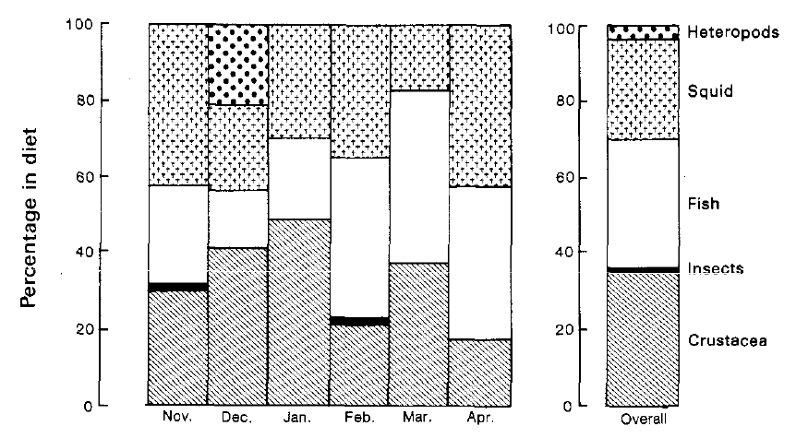

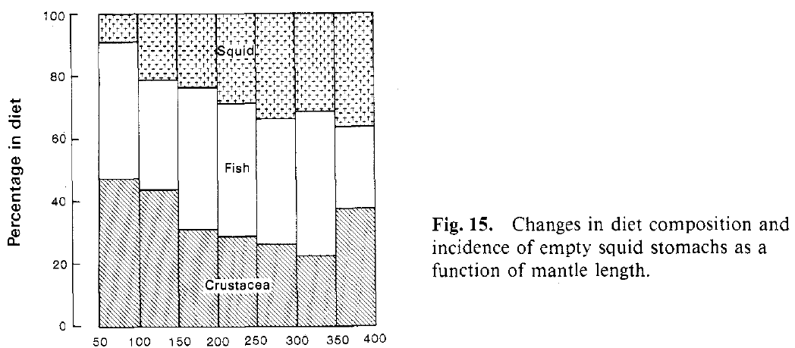

Squid 50 mm

|  |  |
| --- | --- |
| **prey item** | **probability of consuming** |
| MAZ | 0.3 |
| PRW | 0.3 |
| ZME | 0.3 |
| BG | 0.3 |
| SAR | 0.2 |
| FSR | 0.2 |
| CEP | 0.05 |

Squid 100 mm

|  |  |
| --- | --- |
| **prey item** | **probability of consuming** |
| MAZ | 0.3 |
| PRW | 0.3 |
| ZME | 0.3 |
| BG | 0.3 |
| SAR | 0.15 |
| FSR | 0.15 |
| CEP | 0.07 |

Squid 150 mm

|  |  |
| --- | --- |
| **prey item** | **probability of consuming** |
| MAZ | 0.25 |
| PRW | 0.25 |
| ZME | 0.25 |
| BG | 0.25 |
| SAR | 0.20 |
| FSR | 0.20 |
| CEP | 0.07 |

Squid 200 mm

|  |  |
| --- | --- |
| **prey item** | **probability of consuming** |
| MAZ | 0.2 |
| PRW | 0.2 |
| ZME | 0.2 |
| BG | 0.2 |
| SAR | 0.25 |
| FSR | 0.25 |
| CEP | 0.1 |

Squid 250 mm

|  |  |
| --- | --- |
| **prey item** | **probability of consuming** |
| MAZ | 0.18 |
| PRW | 0.18 |
| ZME | 0.18 |
| BG | 0.18 |
| SAR | 0.25 |
| FSR | 0.25 |
| CEP | 0.2 |

Squid 300 mm

|  |  |
| --- | --- |
| **prey item** | **probability of consuming** |
| MAZ | 0.17 |
| PRW | 0.17 |
| ZME | 0.17 |
| BG | 0.17 |
| SAR | 0.3 |
| FSR | 0.3 |
| CEP | 0.2 |

Squid 350 mm

|  |  |
| --- | --- |
| **prey item** | **probability of consuming** |
| MAZ | 0.15 |
| PRW | 0.15 |
| ZME | 0.15 |
| BG | 0.15 |
| SAR | 0.3 |
| FSR | 0.3 |
| CEP | 0.2 |

Squid 400 mm

|  |  |
| --- | --- |
| **prey item** | **probability of consuming** |
| MAZ | 0.25 |
| PRW | 0.25 |
| ZME | 0.25 |
| BG | 0.25 |
| SAR | 0.2 |
| FSR | 0.2 |
| CEP | 0.3 |

CEP summary for matrix

|  |  |
| --- | --- |
| MAZ | 0.27 |
| PRW | 0.27 |
| ZME | 0.27 |
| BG | 0.27 |
| SAR | 0.2 |
| FSR | 0.2 |
| CEP | 0.2 |

References

D. O'Sullivana.and J. M. Cullen 1983 Food of the Squid ***Nototodarus gouldi*** in Bass Strait.*Aust. J. Mar. Freshw. Res.*34,261-85

